**MINISTRY OF EDUCATION AND SCIENCE OF UKRAINE**

**KHARKOV NATIONAL UNIVERSITY OF**

**RADIOELECTRONICS**

Education Center in English

Student of Specialty Computer Engineering

**Subject**: **Internet Technology**

Laboratory Work Report No: 5

|  |  |
| --- | --- |
| **Student**: | **Course Chief:** |
| Ngwu Victor | Ganna Zavolodko |
| KIYKLI: 18-2 |  |

**2021**

5 practical work - PHP

Task 1.

Editing records. In your site menu, create a topic item "administration", which organizes the addition of records using the SQL command in the table for your version of the course project. A script file that processes data entry via a form to upload to GitHUB.

Task 2.

Display records. On the site page, create a list of records using the SQL language command. A script file that processes data entry through a form to upload to GitHUB.

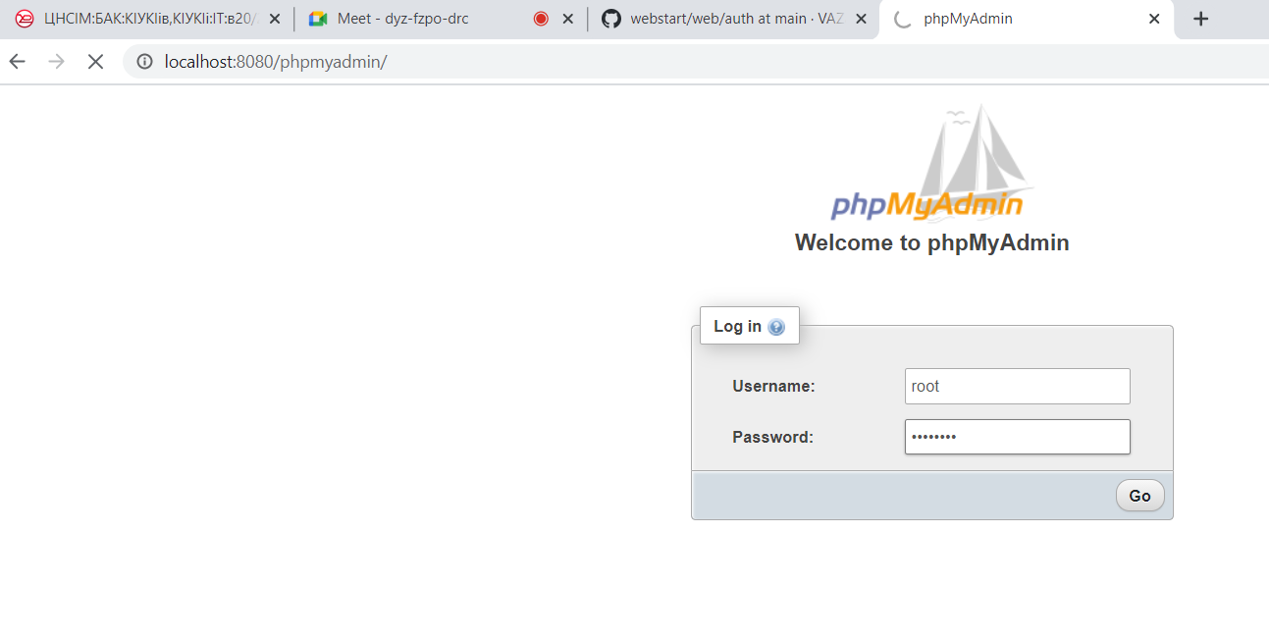

Figure is the admin page of php

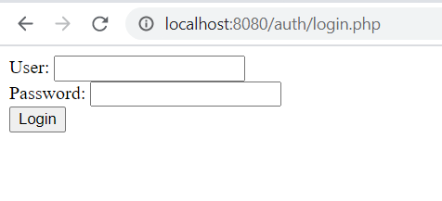

Figure is login page of php

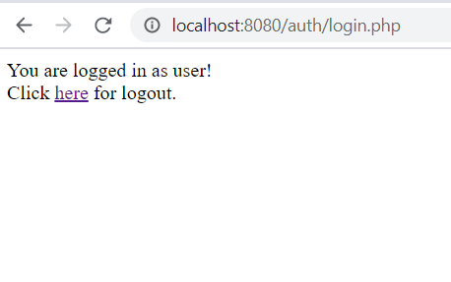

Figure is successful login using php

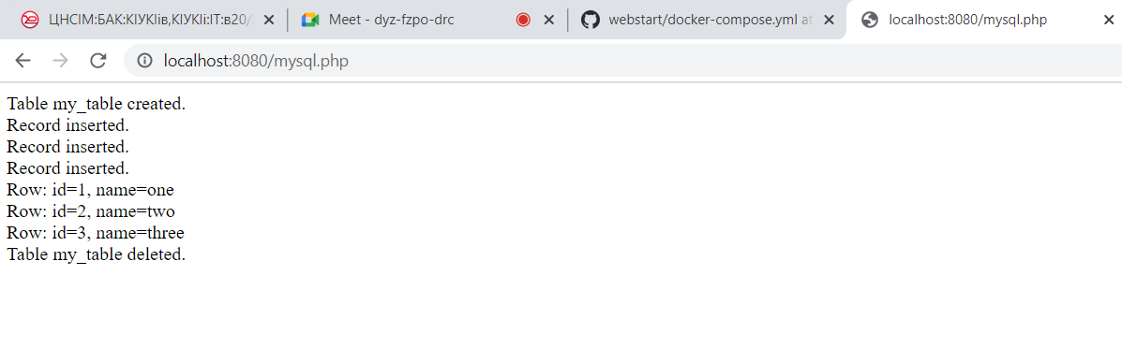

Figure is mysql example

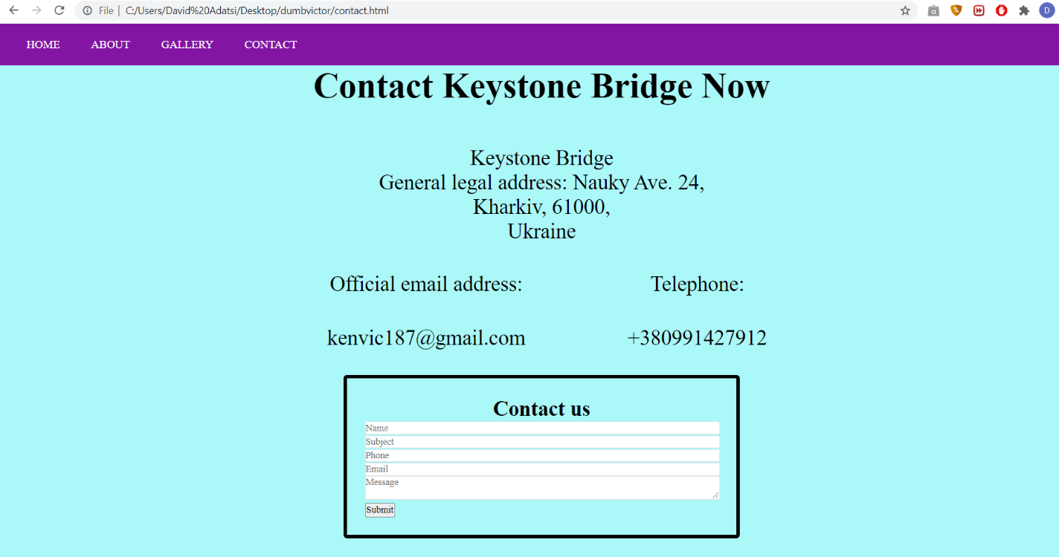

Figure is creation of contact page using JavaScript

**Conclusion**

Using Microsoft visual studio code, we were able to perform a set of tasks for the lab which was to create form for my website. As you can see in the numerous figures above, the task was successfully performed. As a result, a greater understanding on html and CSS and php has been gained and an understanding in JavaScript forms has been obtained. A link to the task is provided below:

https://github.com/NgwuVictor/Internet-Technology/tree/it-task-5

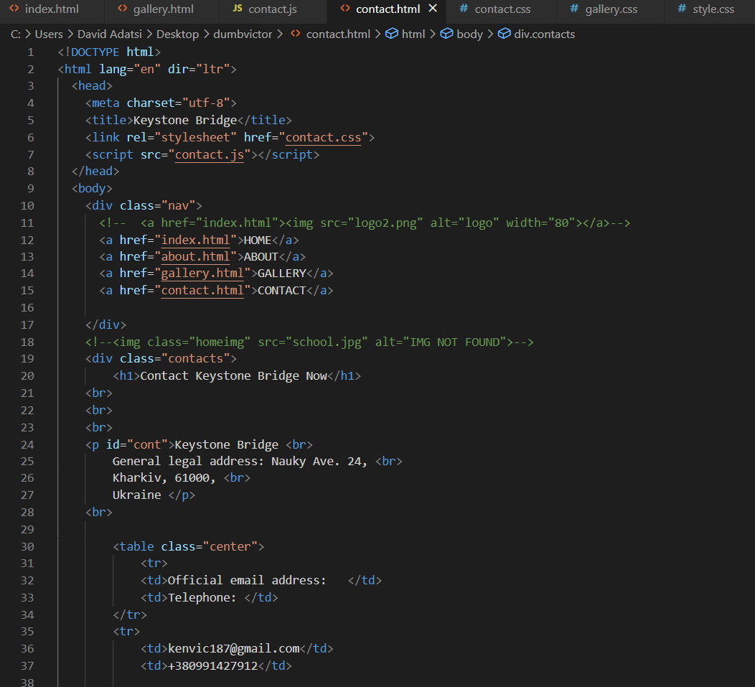

Figure is the code for contact